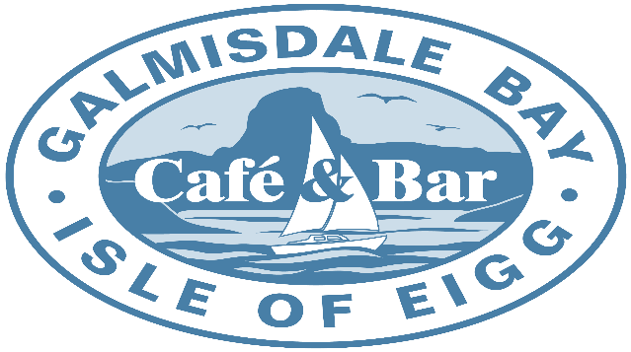
Draught |  |  |  |  |  | Cider (Cans/Bottles)
Pint Guinness |  |  |  | £5.90 |  | Scrumpy Jack 500ml can |  |  |  |  |  |  | £3.00
Pint Eigg IPA |  |  |  | £5.90 |  | Thatchers Gold 500ml Can |  |  |  |  |  |  | £3.00
Pint Eigg Pilsner |  |  |  | £5.90 |  | Henry Westons Vintage 500ml Bottle |  |  |  |  |  |  | £4.50
Pint Stowford Press Cider |  |  |  | £4.50 |  | Magners apple 568ml Bott |  |  |  |  |  |  | £4.50
1/2 Pt Guinness |  |  |  | £3.10 |  | Magners Pear 568ml Bott |  |  |  |  |  |  | £4.50
1/2 Pt Eigg IPA |  |  |  | £3.10
1/2 Pt Eigg Pilsner |  |  |  | £3.10 |  | Spirit’s
1/2 Pt Stowford Press Cider |  |  |  | £2.30
 |  |  |  |  |  | Grouse 35ml |  |  |  |  |  |  | £3.90
Ale & Stout (Cans/Bottles) |  |  |  |  |  | Malt Whisky 35ml |  |  |  |  |  |  | £5.50
 |  |  |  |  |  | Smirnoff Vodka 35ml |  |  |  |  |  |  | £3.90
Guinness 440ml Can |  |  |  | £3.80 |  | Gordons Gin 35ml |  |  |  |  |  |  | £3.90
Mcewans Export 500ml Cans |  |  |  | £3.50 |  | Bombay Saphire Gin 35ml |  |  |  |  |  |  | £4.00
Drygate Gladeye IPA 440ml can |  |  |  | £4.50 |  | Hendricks Gin 35ml |  |  |  |  |  |  | £4.30
Cairngorm gold 500ml Bott |  |  |  | £5.25 |  | Jack Daniels |  |  |  |  |  |  | £3.90
Brewdog 0% Alcohol IPA |  |  |  | £2.50
 |  |  |  |  |  | OVD Dark Rum 35ml |  |  |  |  |  |  | £3.90
Lager’s (Cans/Bottles) |  |  |  |  |  | Kraken Dark Spiced Rum 35ml |  |  |  |  |  |  | £4.30
 |  |  |  |  |  | Dead Man’s Fingers Spiced Rum |  |  |  |  |  |  | £4.30
Drygate Bearface Lager 440ml can |  |  |  | £4.50 |  | Bacardi Rum 35ml |  |  |  |  |  |  | £3.90
Budvar 500ml Bott |  |  |  | £4.50 |  | Morgans Spice 35ml |  |  |  |  |  |  | £3.90
San Miguel 500ml Can |  |  |  | £3.50 |  | Southern Comfort 35ml |  |  |  |  |  |  | £3.90
Kronenbourg 440ml can |  |  |  | £3.50 |  | Sambucca 35ml |  |  |  |  |  |  | £3.00
Peroni 330ml Bott |  |  |  | £3.50 |  | Tequila 35ml |  |  |  |  |  |  | £3.00
0% Alcohol Peroni |  |  |  | £2.25 |  | Baileys 50ml |  |  |  |  |  |  | £4.00
 |  | Wine
House Cabernet Sauvignon |  |  |  |  |  | 175ml £4.20 |  |  |  | 250ml £6.00 |  | Bottle £16.00
House Merlot |  |  |  |  |  | 175ml £4.30 |  |  |  | 250ml £6.30 |  | Bottle £18.00
Monte Clavijo Rioja Tempranillo |  |  |  |  |  |  |  |  |  |  |  | Bottle £26.50
House Sauvignon Blanc |  |  |  |  |  | 175ml £4.20 |  |  |  | 250ml £6.00 |  | Bottle £16.00
House Pinot Grigio |  |  |  |  |  | 175ml £4.20 |  |  |  | 250ml £6.00 |  | Bottle £16.00
 | Trulli Prosecco Brut |  |  |  |  |  |  | Bottle £28.00
 | Corte Vigna Pinot Grigio Rose |  |  |  |  |  |  | Bottle £18.00
Alcohol Menu

