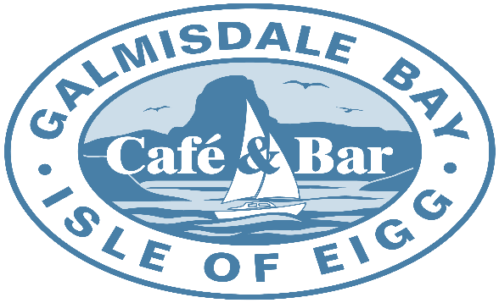
Daytime Menu
Hot Filled Rolls |  |  | Cold Filled Rolls
Fried Eigg | £3.50 |  | Cheese Salad | £4.00
Potato Scone | £3.50 |  | Vegan Cheese Salad | £4.00
Bacon | £3.60 |  | Tuna Mayo Salad | £4.00
Sausage | £3.60 |  | Ham Salad | £4.00
Veggie Sausage | £3.60 |  | Eigg Mayo Salad | £4.00
Vegan Sausage | £3.60 |  | Prawn Mayo Salad | £6.00
Stornaway Black Pudding | £3.60
Haggis | £3.60 |  | Salad Bowls
Veggie Haggis | £3.60
Vegan Haggis | £3.60 |  | Cheese | £4.50
Double Decker (Choose 2 Fillings from above) | £4.50 |  | Vegan Cheese | £4.50
Triple Decker (Choose 3 Fillings from above) | £5.25 |  | Tuna Mayo | £4.50
BLT (Bacon, Lettuce and Tomato) | £4.50 |  | Eigg Mayo | £4.50
 |  |  | Prawn Mayo | £6.75
Paninis (Served with Salad and Coleslaw) |  |  | Leaf Salad (Inc. Onion, Tomato and Cucumber) | £2.50
 |  |  | Coleslaw | £3.00
Brie, Cranberry and Bacon | £7.75 |  | Vegan Coleslaw | £3.00
Mozzarella, Pesto and Tomato | £7.75
Tuna and Cheese Melt | £7.75 |  | Soup (Check Specials Board for today’s Soups)
Vegan Haggis and Vegan Cheese Melt | £7.75
Haggis and Cheese Melt | £7.75 |  | Soup and a Plain Roll | £5.00
Cajun Chicken, Mozzarella, Pesto and Tomato | £8.75 |  | Soup and a Cold Filled Roll (Exluding Prawns) | £7.50
Make Your own (Choose 2 Fillings from below) | £7.75 |  | Soup and a Prawn Roll | £9.75
 |  |  | Soup and a Hot Filled Roll (1 Filling) | £7.50
Fillings |  |  | Soup and a BLT or Double Decker | £8.10
Cheese, Vegan Cheese, Mozzarella, Brie, Ham, |  |  | Soup and a Panini (2 fillings only) | £8.10
Bacon, Tomato, Haggis, Vegan Haggis, |  |  | Cullen Skink and a Plain Roll | £7.50
Veggie Haggis, Tuna Mayo, Cajun Chick (+£1)
 |  |  | Baked Potatoes (Served with Salad and Coleslaw)
Fillings that can be added to any Panini for Free
Pesto, Cranberry and Onion |  |  | Cheese and Beans | £7.75
 |  |  | Vegan Cheese and Beans | £7.75
Burgers |  |  | Tuna Mayo and Cheese | £7.75
 |  |  | Haggis and Cheese | £7.75
Burger with Salad Garnish | £6.00 |  | Vegan Haggis and Vegan Cheese | £7.75
Burger with Salad, Coleslaw and Chips | £9.50 |  | Prawns | £9.50
 |  |  | Make Your Own with 2 Fillings (Choose from Below) | £7.75
Choose From |  |  | Make Your Own with 3 Fillings (Choose from Below) | £8.25
Beef, Cajun Chicken, Veggie or Vegan
 |  |  | Fillings
Add Cheese or Vegan Cheese | £1.00 |  | Cheese, Vegan Cheese, Eigg Mayo, Tuna Mayo,
Add 1 slice of Bacon | £1.00 |  | Beans, Haggis, Veggie Haggis, Vegan Haggis,
 |  |  | Prawns (+£1.75)
P.T.O.
Daytime Menu
Other Lunchtime |  |  | Drinks
Fish Cakes | £11.50 |  | Filter Coffee | £2.10
Mussels | £13.50 |  | Instant Coffee | £1.80
Mac N Cheese | £8.00 |  | Tea | £1.80
 |  |  | Earl Grey | £2.00
 |  |  | Herbal Tea | £2.00
 |  |  | Hot Chocolate | £2.10
 |  |  | Milk | £1.70
Light Bites and Sides |  |  | Flavoured Milk | £1.90
 |  |  | Pure Orange / Apple Juice | £1.20
Chips | £2.75 |  | Diluting Juice | £0.75
Breaded Mushrooms | £3.00 |  | Soft Drinks | £1.60
Salt and Pepper Squid | £3.95 |  | Bottled Water | £1.70
Jalapeno Poppers | £3.25
Mozzarella Sticks | £3.00
Mac & Cheese Bites | £3.25
Sour Cream & Chive Dip | £0.00
Garlic Mayo Dip | £0.00 |  | Cakes
Saracha (Chilli) Dip | £0.00
 |  |  | A selection of homemade cakes available daily.
 |  |  | Ranging from £2 - £3.50.
 |  |  | Ask Staff for details.
P.T.O.

