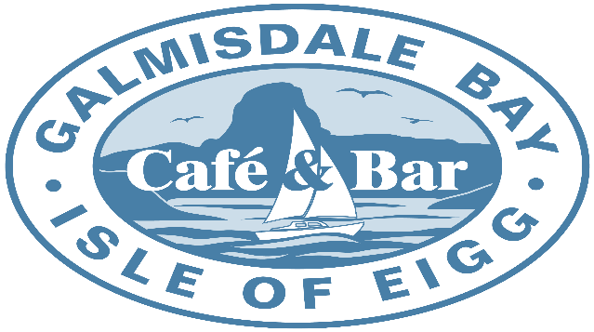
Draught |  |  |  |  |  | Cider (Cans/Bottles)
Pint Guinness |  |  |  | £5.90 |  | Scrumpy Jack 500ml can |  |  |  |  |  |  | £3.00
Pint Eigg IPA |  |  |  | £6.50 |  | Thatchers Gold 500ml Can |  |  |  |  |  |  | £3.00
Pint Eigg Pilsner |  |  |  | £6.50 |  | Henry Westons Vintage 500ml Bottle |  |  |  |  |  |  | £4.50
Pint Stowford Press Cider |  |  |  | £4.50 |  | Magners apple 568ml Bott |  |  |  |  |  |  | £4.50
1/2 Pt Guinness |  |  |  | £3.10 |  | Magners Pear 568ml Bott |  |  |  |  |  |  | £4.50
1/2 Pt Eigg IPA |  |  |  | £3.60
1/2 Pt Eigg Pilsner |  |  |  | £3.60 |  | Spirit’s
1/2 Pt Stowford Press Cider |  |  |  | £2.30
 |  |  |  |  |  | Grouse 35ml & 70ml |  |  |  |  |  | £3.50 | £6.00
Ale & Stout (Cans/Bottles) |  |  |  |  |  | Malt Whisky 35ml & 70ml |  |  |  |  |  | £5.00 | £9.00
 |  |  |  |  |  | Smirnoff Vodka 35ml & 70ml |  |  |  |  |  | £3.50 | £6.00
Guinness 440ml Can |  |  |  | £3.70 |  | Gordons Gin 35ml & 70ml |  |  |  |  |  | £3.50 | £6.00
Mcewans Export 500ml Cans |  |  |  | £3.40 |  | Bombay Saphire Gin 35ml |  |  |  |  |  |  | £4.00
Drygate Gladeye IPA 440ml can |  |  |  | £4.50 |  | Hendricks Gin 35ml |  |  |  |  |  |  | £4.30
Cairngorm gold 500ml Bott |  |  |  | £5.25 |  | Other Craft Gin
Eigg Brewery |  |  |  |  |  | Other Craft Gin
 |  |  |  |  |  | OVD Dark Rum 35ml & 70ml |  |  |  |  |  | £3.50 | £6.00
Lager’s (Cans/Bottles) |  |  |  |  |  | Kraken Dark Spiced Rum 35ml |  |  |  |  |  |  | £4.00
 |  |  |  |  |  | Other Rum
Drygate Bearface Lager 440ml can |  |  |  | £4.50 |  | Bacardi Rum 35ml & 70ml |  |  |  |  |  | £3.50 | £6.00
Budvar 500ml Bott |  |  |  | £4.50 |  | Morgans Spice 35ml |  |  |  |  |  |  | £3.50
San Miguel 500ml Can |  |  |  | £3.50 |  | Southern Comfort 35ml |  |  |  |  |  |  | £3.50
Kronenbourg 440ml can |  |  |  | £3.50 |  | Sambucca 35ml |  |  |  |  |  |  | £3.00
Peroni 330ml Bott |  |  |  | £3.50 |  | Tequila 35ml |  |  |  |  |  |  | £3.00
Eigg Brewery |  |  |  |  |  | Baileys 50ml |  |  |  |  |  |  | £3.95
Eigg Brewery
 |  | Wine
Los Tilos Cabernet Sauvignon |  |  |  |  |  | 175ml £4.20 |  |  |  | 250ml £6.00 |  | Bottle £16.00
Luis Felipe Edwards Lot 18 Merlot |  |  |  |  |  | 175ml £4.30 |  |  |  | 250ml £6.30 |  | Bottle £18.00
Monte Clavijo Rioja Tempranillo |  |  |  |  |  |  |  |  |  |  |  | Bottle £26.50
Laderas Sauvignon Blanc 175ml |  |  |  |  |  | 175ml £4.20 |  |  |  | 250ml £6.00 |  | Bottle £16.00
Antonio Rubini Pinot Grigio 175m |  |  |  |  |  | 175ml £4.20 |  |  |  | 250ml £6.00 |  | Bottle £16.00
 | Trulli Prosecco Brut |  |  |  |  |  |  | Bottle £28.00
 | Corte Vigna Pinot Grigio Rose |  |  |  |  |  |  | Bottle £18.00
Alcohol Menu

